**Practical No. 02**

**Aim:** Setting up GitHub Account

The first steps in starting with GitHub are to create an account, choose a product that fits your needs best, verify your email, set up two-factor authentication, and view your profile.

There are several types of accounts on GitHub. Every person who uses GitHub has their own user account, which can be part of multiple organisations and teams. Your user account is your identity on GitHub.com and represents you as an individual.

1. **Creating an account:** To sign up for an account on GitHub.com, navigate to https://github.com/ and follow the prompts. To keep your GitHub account secure you should use a strong and unique password.

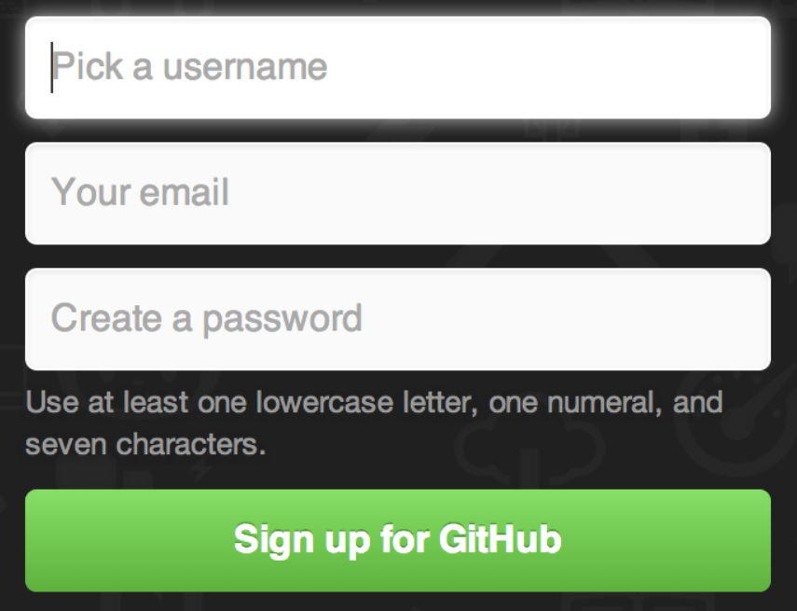

2. **Choosing your GitHub product:** You can choose GitHub Free or GitHub Pro to get access to different features for your personal account. You can upgrade at any time if you are unsure at first which product you want. For more information on all GitHub’s plans, see “GitHub's products”.

3. **Verifying your email address:** To ensure you can use all the features in your GitHub plan, verify your email address after signing up for a new account. 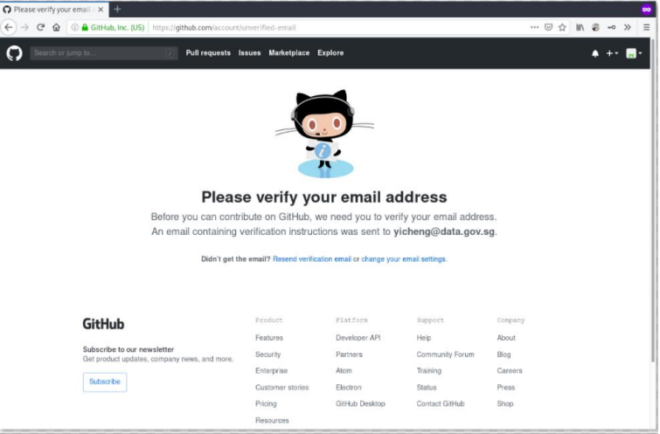

4. Configuring two-factor authentication: Two-factor authentication, or 2FA, is an extra layer of security used when logging into websites or apps. We strongly urge you to configure 2FA for safety of your account. For more information, see “About twofactor authentication."

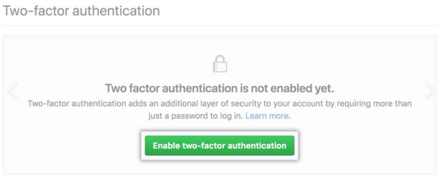

5. Viewing your GitHub profile and contribution graph: Your GitHub profile tells people the story of your work through the repositories you’ve pinned, the organisation memberships you’ve chosen to publicize, the contributions you’ve made, and the projects you’ve created. For more information, see “About your profile” and “Viewing contributions on your profile.”